In this user session we are signed in as customer id 4.

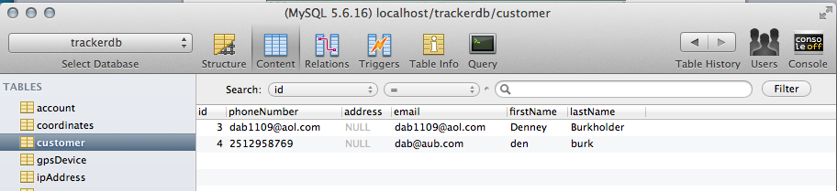

As you can see, customer id 4 has no registered laptop devices at this time.

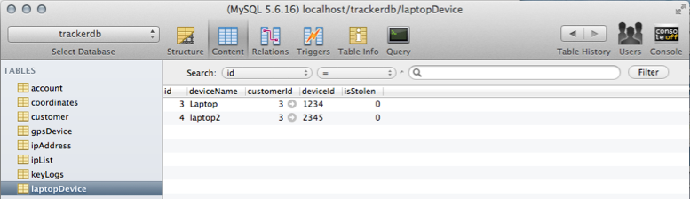

After logging in as customer 4, the user is redirected to the map page. This alert is for testing purposes and displays the devices registered to the customer along with information pertaining to the devices. Customer 4 doesn’t have any registered devices, so the alert is null.

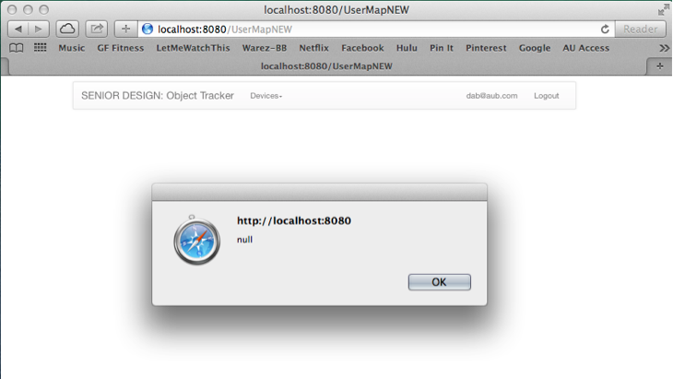

Once the map page is fully loaded, this is what the customer 4 sees. When clicking on the “Devices” tab, customer 4’s only choice is to “Add Device”.

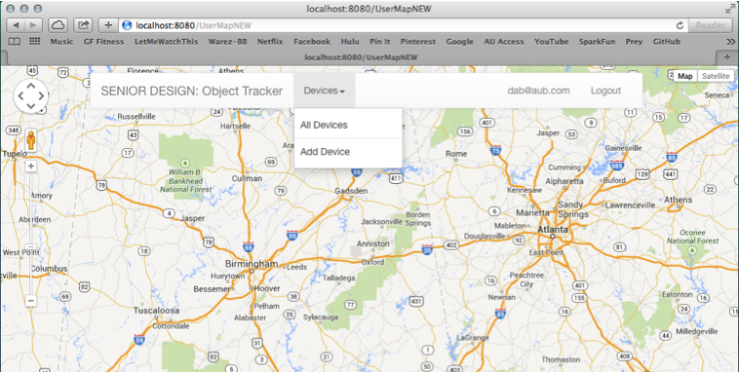

When customer 4 clicks “Add Device” the “New Device” window pops up.

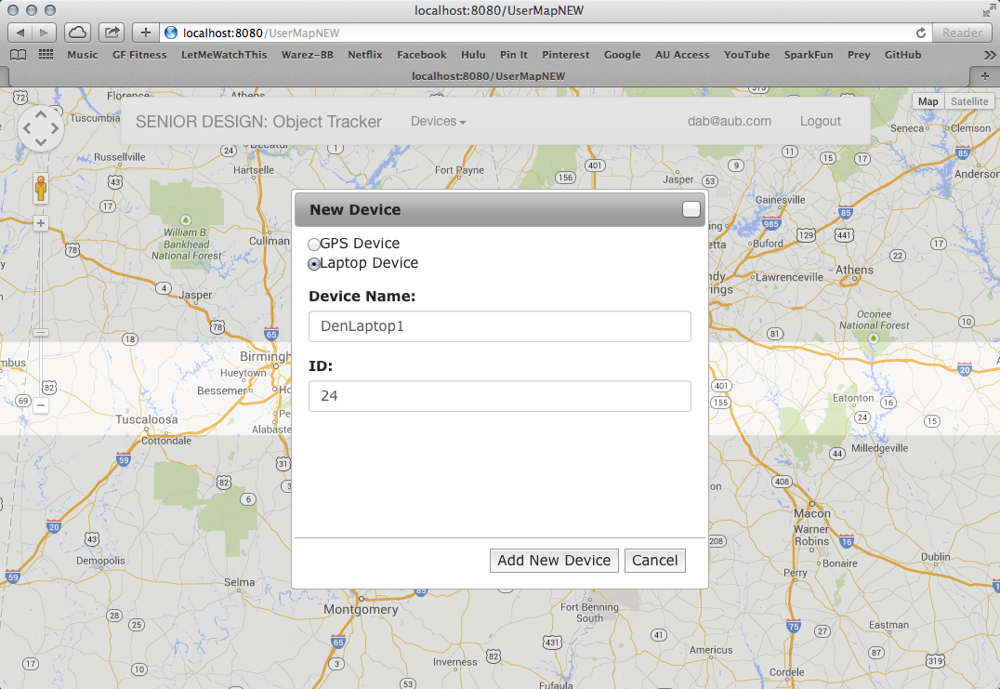’

For our testing purposes, an alert pops up with whether adding the new device to the database was a success or fail. Our add was a success.

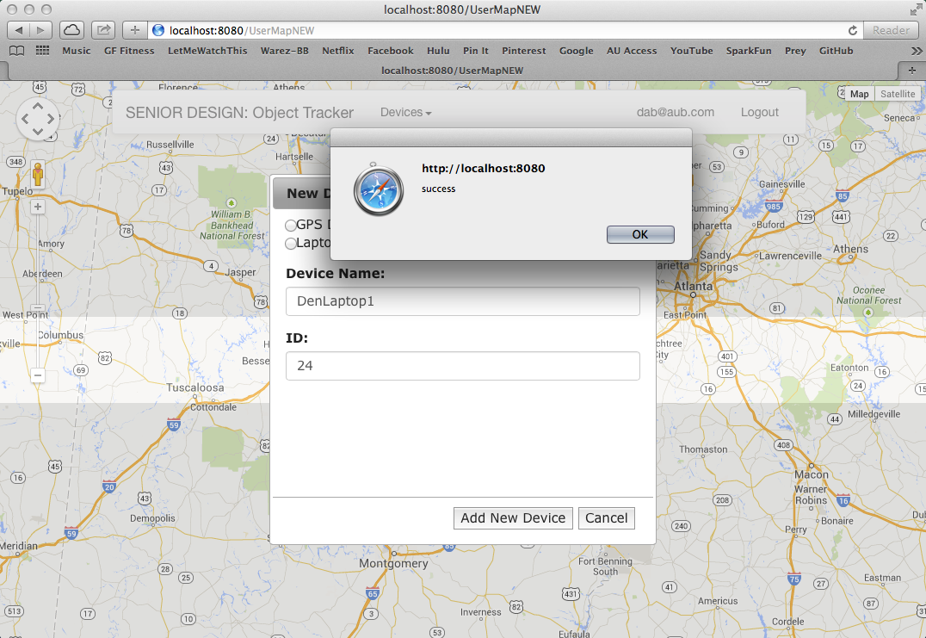

Here is the added device reflected in the database.

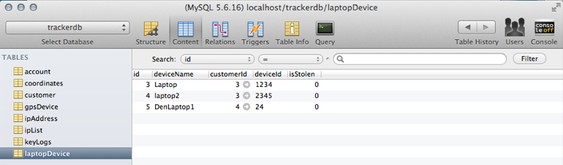

Now when customer 4 refreshes the map page, the alert shows the information regarding the device we just added.

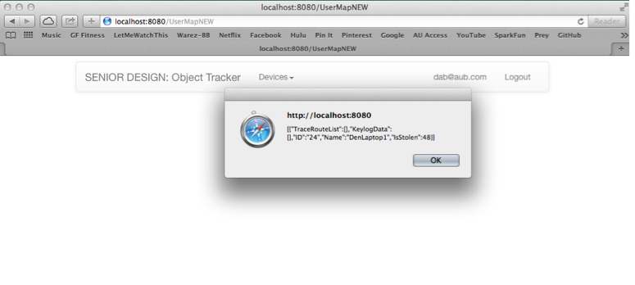

And the “Devices” dropdown now reflects the newly added device.

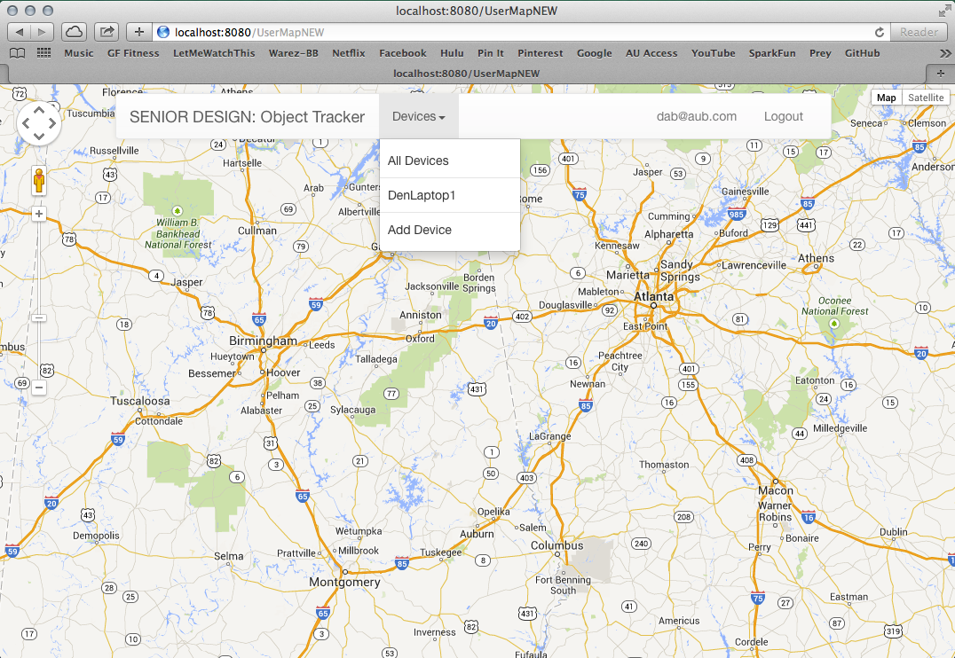

Selecting the “DenLaptop1” options from the dropdown menu displays options for viewing the information pertaining to the “DenLaptop1” device.

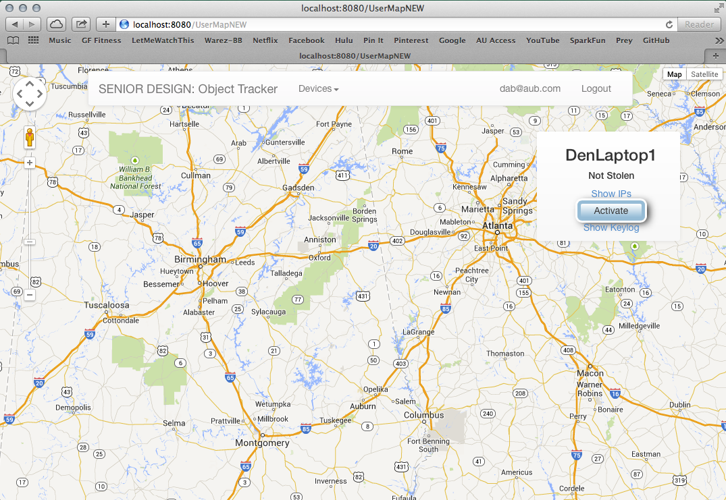

If customer 4 adds another laptop device the results are the same.

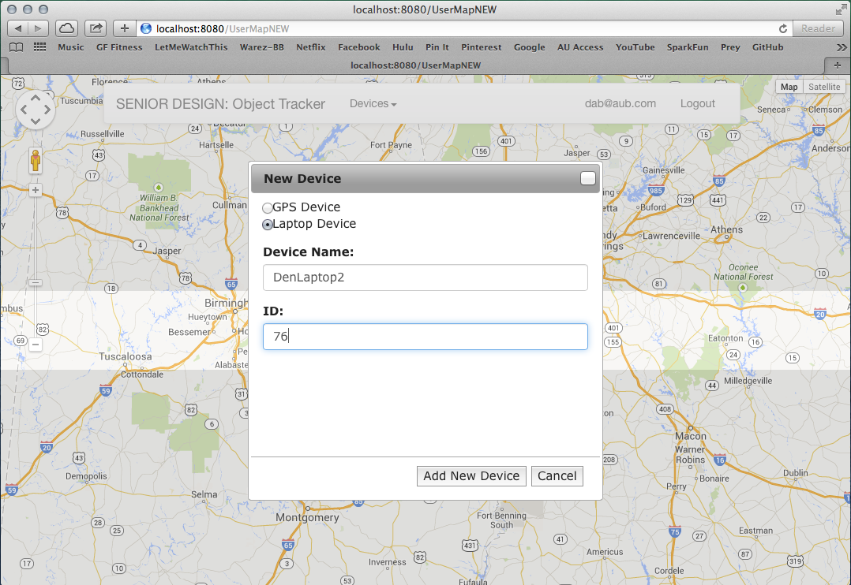

The alert now contains information for two devices.

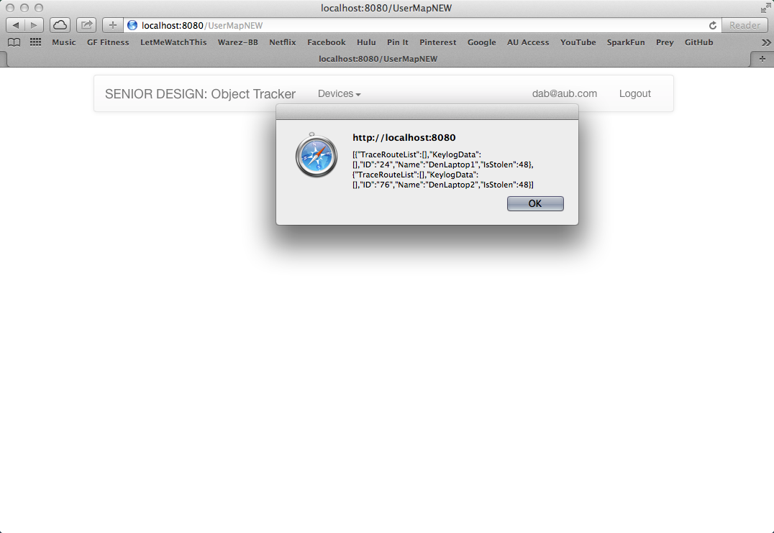

Both devices are displayed in the “Devices” dropdown.

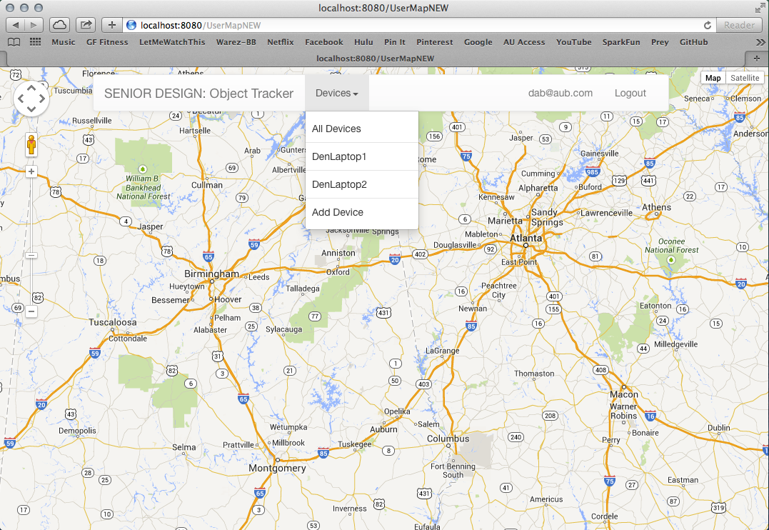

The database now contains two laptop device listings associated with customer 4.

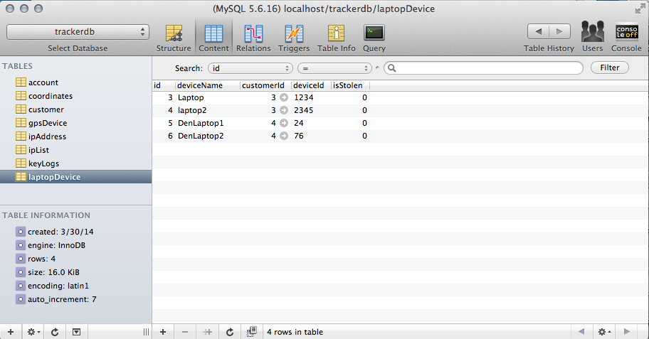

When the user selects “DenLaptop2” from the “Devices” dropdown menu, the information pertaining to that device appears. The user can toggle from this display to viewing “DenLaptop1” by using the “Devices” dropdown menu.

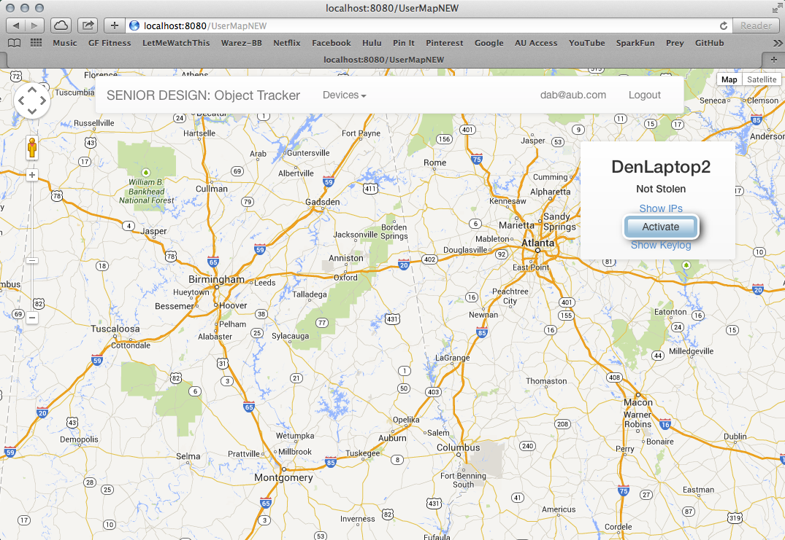

There are no gps devices currently registered in our database.

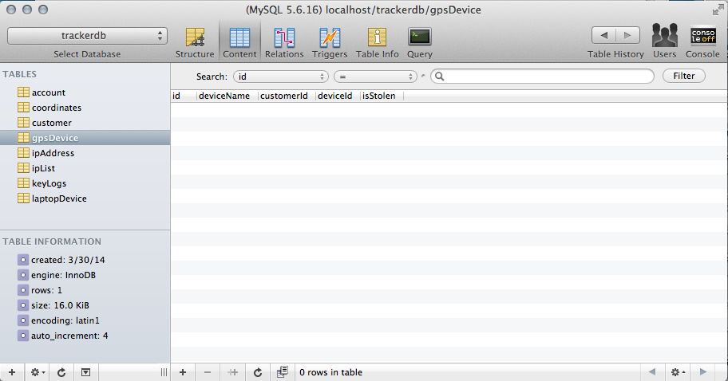

Customer 4 now selectes “Add Device” and inputs a GPS device.

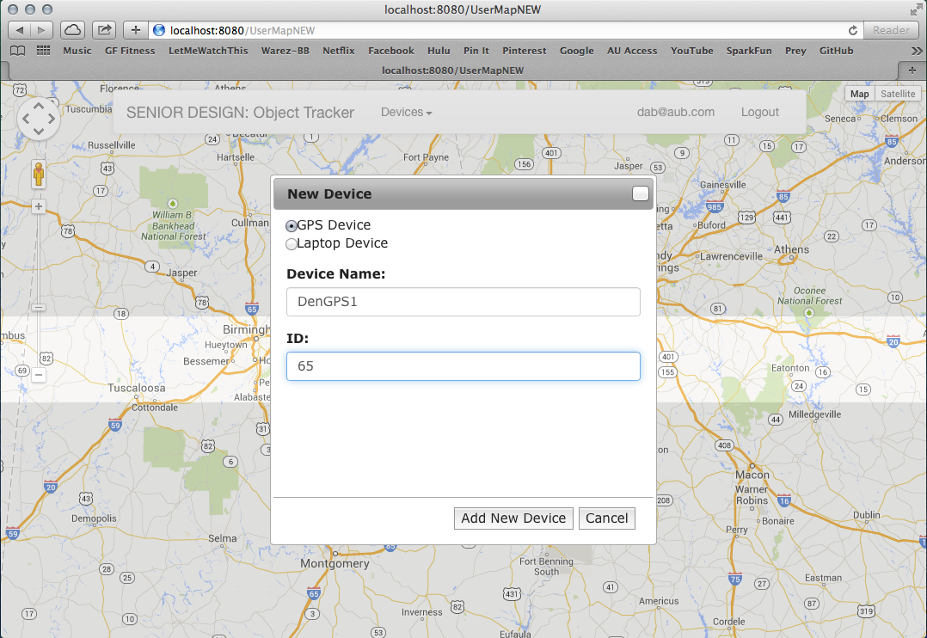

The alert informs us the device was successfully added to the database.

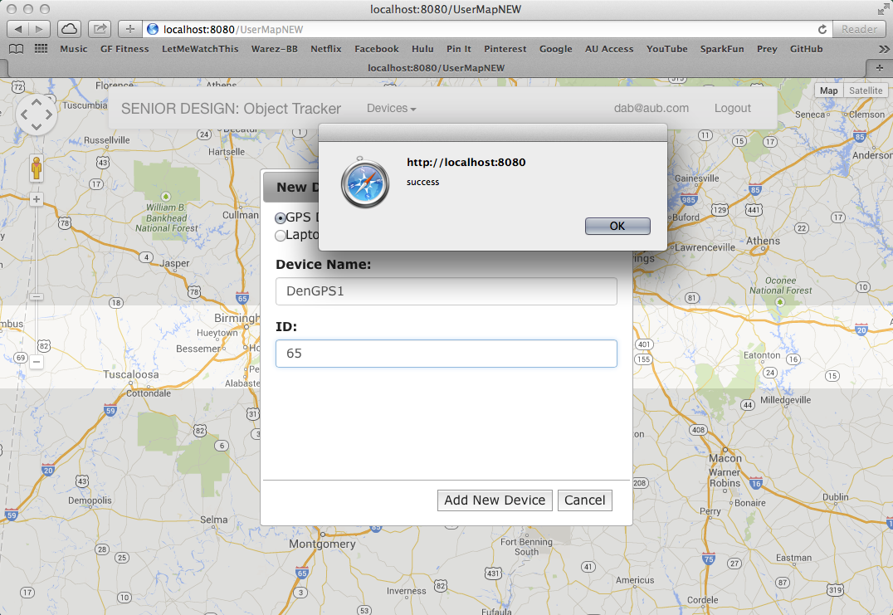

And here we can see a GPS device has been registered to customer 4.

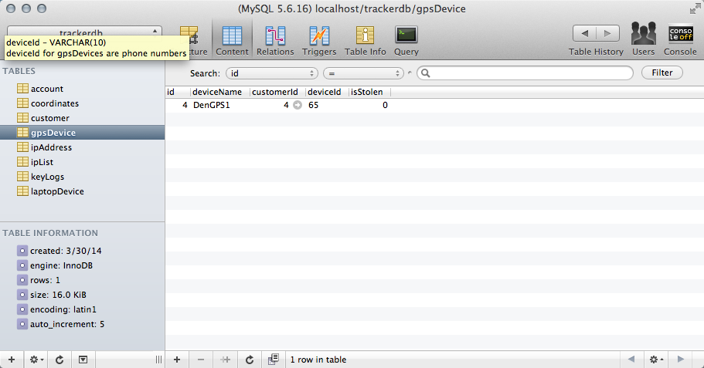

Server updating GPS device coordinates

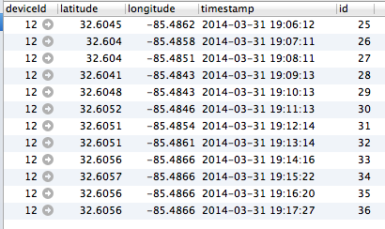

Server receives trace route and keylog data from laptop

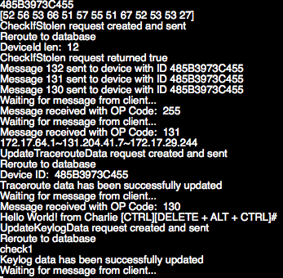

IPList table that holds an id that’ll link all IPs related to one trace route

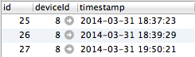

IP address table, listId is a realtion to the IPList table. If the listIds are equal, they are part of the same trace route

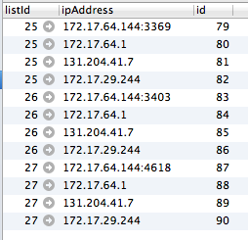

Keylog data stored in the database

MacOSx:Users:leoreyes:Desktop:seniordesign:Screen Shot 2014-03-31 at 8.00.05 PM.png